“The Lightning Box”
Model #334 (120v) or #426 (220v)
List of components included in the system.
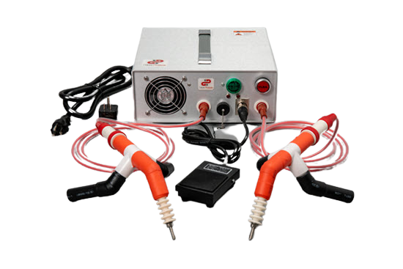
- This system has a 2000v – 500Ma power supply. (1)
- 12 AWG, 20A power cord and universal adapter. (1)
- Plug-in foot switch, 100-250v
- Small adjustable modular probes. (SAPs) (2)
With 80” extension high voltage leads (2)

- This High-Output model required a higher level of electrolytes. It has (2000v) and (500Ma). The electrolyte mixture must be one cup of HOT water and two tablespoons of baking soda. Table salt, borax, and petalite will also work. Prepare the wood by cleaning, sanding, and soaking with electrolytes.

- The power cord is a 12AWG 3-core cord with a 20A NEMA plug. The 15A to 20A adapter is furnished so you can use it in a 15A circuit. Do not allow the amperes to exceed 15A, use the VVR to limit the current.
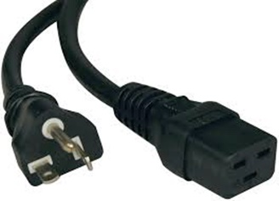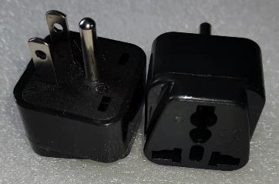

- The foot switch and all other control circuits are separate from the power circuit. Push the release button before pulling the connector out of the panel. Do not yank it, it may break.
- The small adjustable probes (SAPs) have legs that can be turned to adjust the height and angle of the tips. Keep the ceramic insulators clean. Use soap and water. Two 80” high-voltage leads are included.
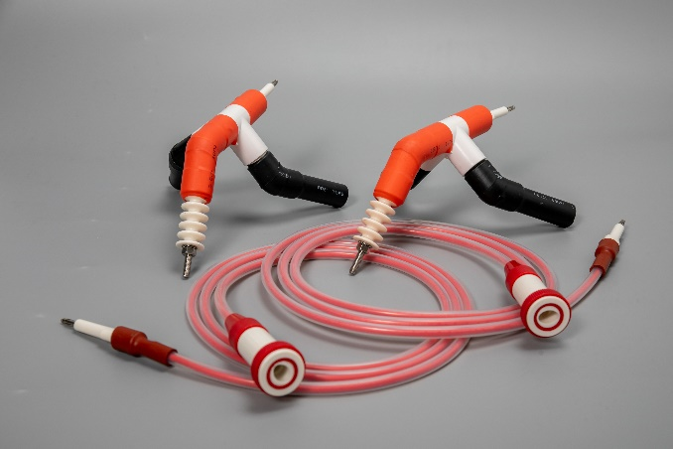

Ground Fault Interrupters (GFIs) do not work with burners. The transformer is an isolated type. The output is isolated from your house circuit.
The High-Voltage accessories are insulated by using ceramics, PVC pipe, PVC shrink tube, silicone wire insulation, PVC sockets and plugs, and silicone tubing. Do not repair damaged insulation with electrical tape. It is only rated for low voltage.
If you buy our Lichtenberg wood burning products and have a repair issue, contact us. I will furnish small repair parts; you pay the air freight. This only applies to small electrical parts.

